**COMPUTER NETWORKS**

**NAME: M.ISTAFA MALIK**

**ROLL: P190033**

**SECTION: BSCS-5A**

**Task: How to configure an email server in Packet Tracer**

**Solution:**

Step 1: Topology

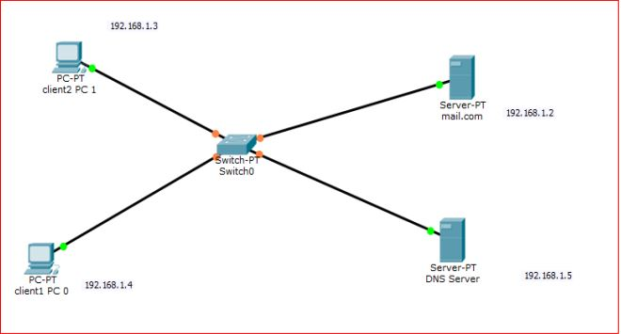

**Step 2:** Configure IP addresses on the PCs, DNS Server and the Mail Serve

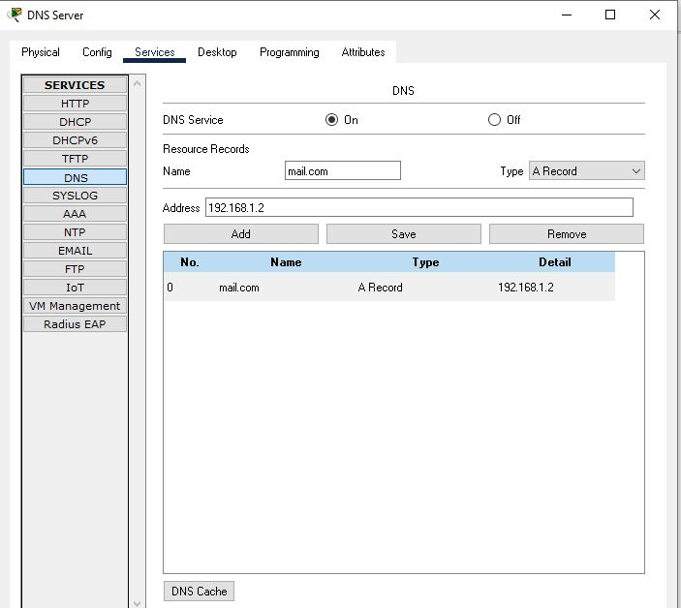

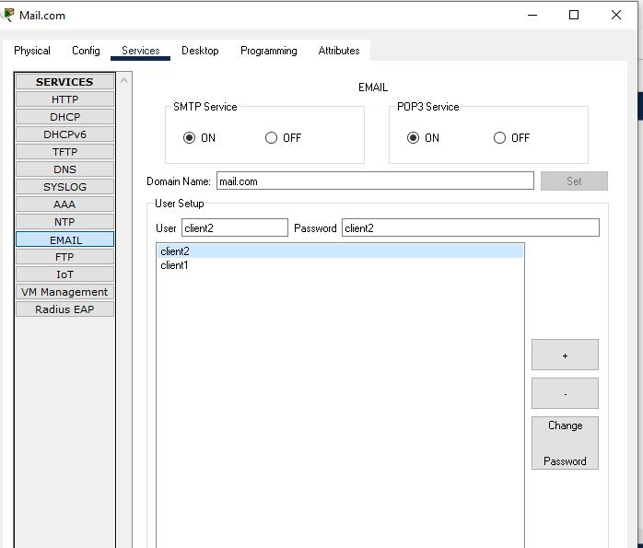

**Step 3: After configuration try sending email.**

